Creating the Methods (Delete)
Completing the Collection Class

Completing the Collection Class 1
Creating the Delete Method 1

Completing the Collection Class

Creating the Delete Method
Start your Git hub day!
The next method we shall test is the Delete method…
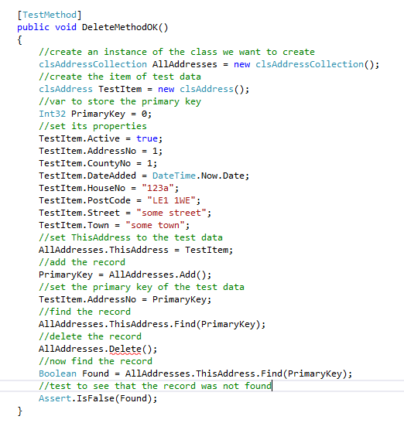
It will fail due to no Delete method. Create the method and watch it fail for lack of suitable code.
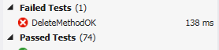
Assuming we have a stored procedure like so…
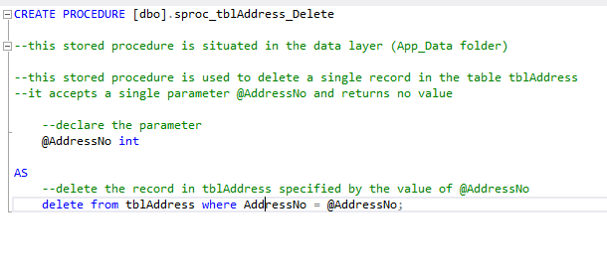
Here is the finished delete method…
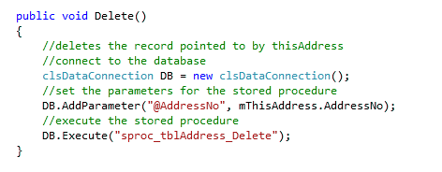
As before we will link the middle layer to the presentation layer.
From the form AddressList.aspx…
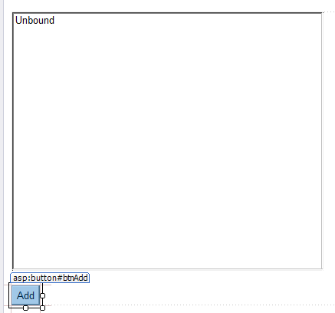
Add a new button for delete called btnDelete and a blank label called lblError like so…
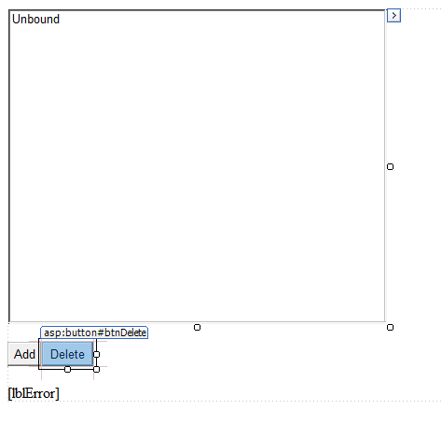
Access the click event handler for Delete and add the following code…
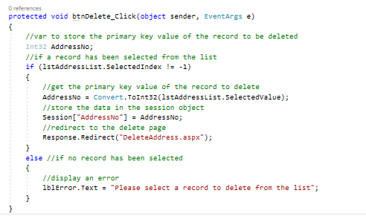
There are few things in this code worth pointing out.
lstAddressList.SelectedIndex != -1 allows us to make sure that an entry on the list has been clicked.
Each item in the list has an index from 0 to N. If the first item is clicked accessing SelectedIndex will produce a value of 0. If nothing has been selected then the SelectedIndex will be 01 so we need to tell the user to click something.
Notice how we access the primary key value via the SelectedValue property.
When we set up the code to display the list from the collection we add the following…
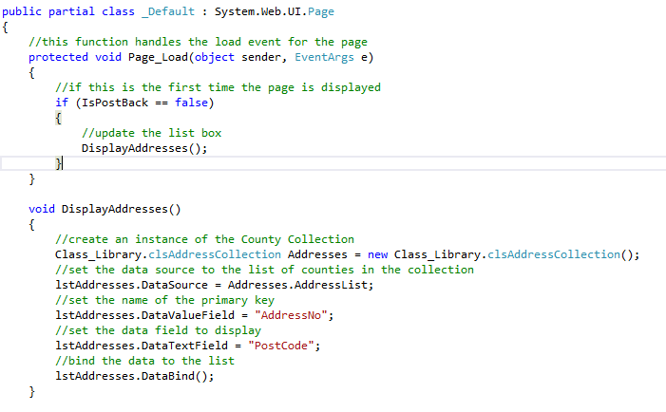
By setting the DataValueText we tell the list which property to display to the user.
By setting the DataValueField we tell the list which property contains the primary key value.
Next you need to create a new web form called DeleteAddress.aspx…
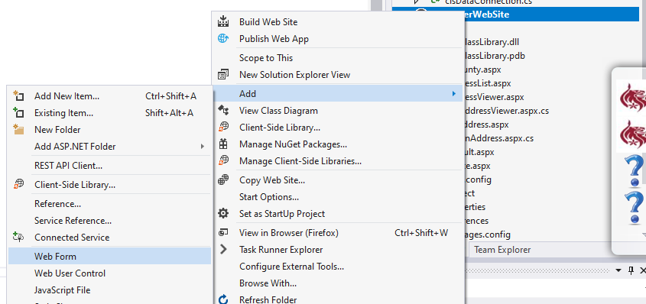

Set the name of the form to DeleteAddress.aspx
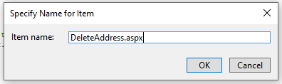
Set up the web form like so…
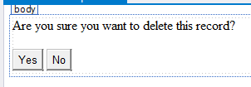
In order to obtain the primary key value of the record to delete we need to access the value stored in the session object.
We will do this via the load event of DeleteAddress.aspx like so…
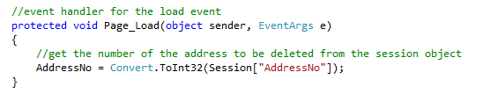
Notice how the variable AddressNo is declared at the top of the code giving it page level scope…
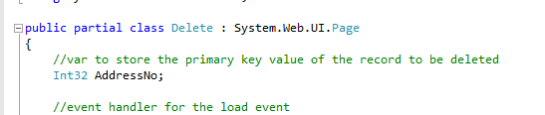
Modify the event handler of the Yes button like so…
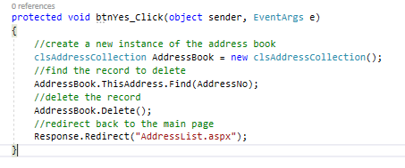
Again test the functionality by running the web site.
Finally end your Git Hub day.

